# **Usability Test Report of Mobile Design**

### **Name of tested web/application**

Eat not meet

### **Place, date**

Bratislava  
29.11.2021 - 05. 12. 2021

## **Summary**

1. No option to save credit card information.  
   We would solve this problem by adding an option to save credit card information.
2. Unnecessary buttons in favourite foods screen.  
   We would solve this problem by replacing the remove button with a cross on the top left part of the picture of the food, just like in the cart.
3. **Test Procedure Description**

### **User Profiles**

### **DUŠAN**

**Age:** 22

**Location:** Bratislava

**Job:** Študent informatiky

**Bio:** Študent informatiky, ktorý momentálne býva na internáte ŠD Mladosť. Má rád dobré jedlo, avšak väčšinu času trávi vo svojej izbe. Je veľmi vyťažený štúdiom a čas, ktorý trávi cestou do jedálne a čakaním v rade by vedel zužitkovať lepšie.

**Needs & Goals:**

- Možnosť jedenia bez sociálnej interakcie a zbytočného pohybu.

- Lacné stravovanie.

**Tech:**

Internet 5/5

Social media 1/5

Online shopping 5/5

**Favourite portals:**

askalot.sk

eat&meet.sk

stackoverflow.com

**Frustrations:**

- Donáškové služby sú predražené.

- Preplnená jedáleň.

### **ALICA**

**Age:** 21

**Location:** Bratislava

**Job:** Študentka filozofie

**Bio:** Študentka filozofie, ktorá momentálne býva na internáte Šturák. Vo voľnom čase sa venuje predaju esenciálnych olejov. Je vegánka. Napriek momentálnej pandemickej situácii nie je očkovaná. To jej značne sťažuje prístup do stravovacích zariadení.

**Needs & Goals:**

- Možnosť jedenia bez testu/očkovania.

- Zdravé, vegánske a cenovo dostupné stravovanie.

**Tech:**

Internet 3/5

Social media 5/5

Online shopping 4/5

**Favourite portals:**

zemavek.sk

zdraveoleje.sk

instagram.com

**Frustrations:**

- Potreba testu/očkovania do jedálne.

- Slabý výber vegánskych, cenovo dostupných jedál.

### **BRAŇO**

**Age:** 25

**Location:** Bratislava

**Job:** Študent FTVŠ

**Bio:** Študent FTVŠ. Keďže sa venuje športu, potrebuje kvalitnú, ale cenovo dostupnú stravu pre študenta. Takéto možnosti však nemá, pretože v jeho okolí sa nenachádza žiadna študentská jedáleň.

**Needs & Goals:**

- kvalitná, ale cenovo dostupná strava

- možnosť stravovania, za ktorým nemusí ďaleko dochádzať

**Tech:**

Internet 2/5

Social media 3/5

Online shopping 1/5

**Favourite portals:**

zlavomat.sk

nike.sk

**Frustrations:**

- v jeho okolí sa nenachádza žiadna študentská jedáleň

- reštaurácie a donáškové služby sú drahé

### **JANO**

**Age:** 22

**Location:** Bratislava

**Job:** Študent EUBA

**Bio:** Študent na ekonomickej univerzite v Bratislave, ktorý býva na internáte Družba. V jeho okolí sa nenachádza žiadna študentská jedáleň a tak si jedlo varí sám. Pravidelne športuje a istý čas sa zaujímal aj o zdravú výživu.

**Needs & Goals:**

- cenovo dostupná strava

- objednanie jedla na internát

**Tech:**

Internet 3/5

Social media 3/5

Online shopping 2/5

**Favourite portals:**

www.florbal4u.cz

www.aliexpress.com

**Frustrations:**

- drahé potraviny a časovo náročná príprava jedál na internáte

### **Test Users**

| **Test User** | **TP1** | **TP2** | **TP3** | **TP4** | **TP5** |
| --- | --- | --- | --- | --- | --- |
| *Alias* | Karin | Nikoleta | Jano | Dušan | Roman |
| *Date of Test* | 5.12.2021 | 6.12.2021 | 5.12.2021 | 4.12.2021 | 5.12.2021 |
| *Time of Test* | 14:36 | 3:34 | 17:58 | 14:00 | 19:30 |
| *Language of Test* | Slovak | Slovak | Slovak | Slovak | Slovak |
| **General Information** | | | | | |
| *Sex* | Female | Female | Male | Male | Male |
| *Age* | 24 | 22 | 22 | 22 | 22 |
| *Education* | FIIT | FFUK | EUBA | FIIT | FIIT |
| **Sight Impairment** | | | | | |
| *Sight Aid* | glasses | no | no | glasses | glasses |
| *Colour Blindness?* | no | no | no | no | no |
| **Education** | | | | | |
| *Education level* | master’s undergraduate | bachelors undergraduate | bachelors undergraduate | bachelors undergraduate | bachelors undergraduate |

**Table 1:** Overview of the test users.

### **Test Environment**

| **Equipment (TP1)** | |
| --- | --- |
| **Device** | Xiaomi Mi 9 SE |
| **Operating System** | Android |
| **Web Browser** | Google Chrome |
| **Internet Connection** | WiFi |
| **Screen Resolution** | Full HD |
| **Screen Size** | 6.4’’ |
| **Equipment (TP2)** | |
| **Device** | Iphone 12 |
| **Operating System** | iOs 15 |
| **Web Browser** | Safari |
| **Internet Connection** | Wifi |
| **Screen Resolution** | OLED |
| **Screen Size** | 6.1” |
| **Equipment (TP3)** | |
| **Device** | Iphone 7 |
| **Operating System** | iOs 14 |
| **Web Browser** | Safari |
| **Internet Connection** | Wifi |
| **Screen Resolution** | 750x1334 pixels |
| **Screen Size** | 4,7’’ |
| **Equipment (TP4)** | |
| **Device** | Samsung Galaxy A50 |
| **Operating System** | Android 11 |
| **Web Browser** | Samsung Internet Browser |
| **Internet Connection** | Wifi |
| **Screen Resolution** | Full HD |
| **Screen Size** | 6.4’’ |
| **Equipment (TP5)** | |
| **Device** | Iphone 8 |
| **Operating System** | iOS 14.8.1 |
| **Web Browser** | Google Chrome |
| **Internet Connection** | Wifi |
| **Screen Resolution** | Full HD |
| **Screen Size** | 5” |

**Table 2:** Environment used for the thinking aloud test.

### **Test environment**

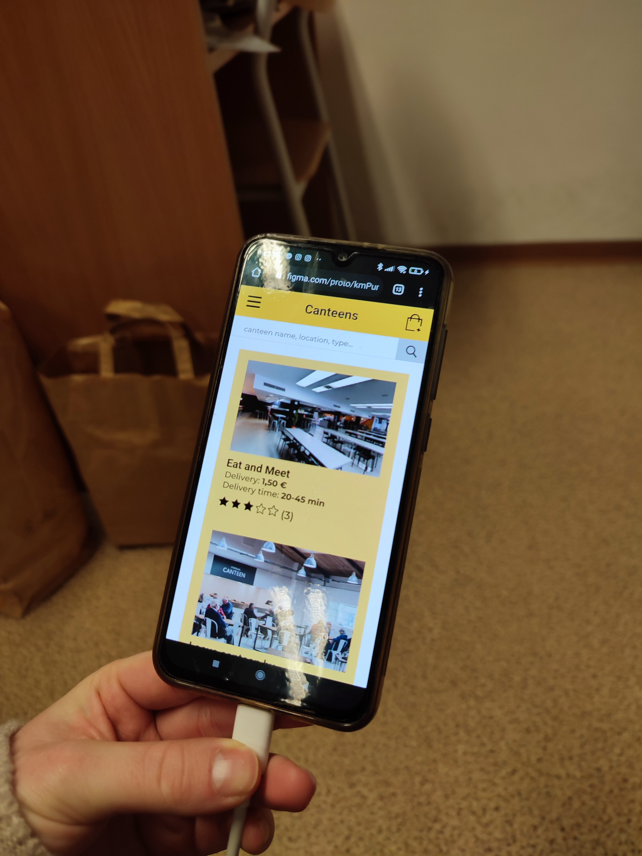**TP1**

**TP2**

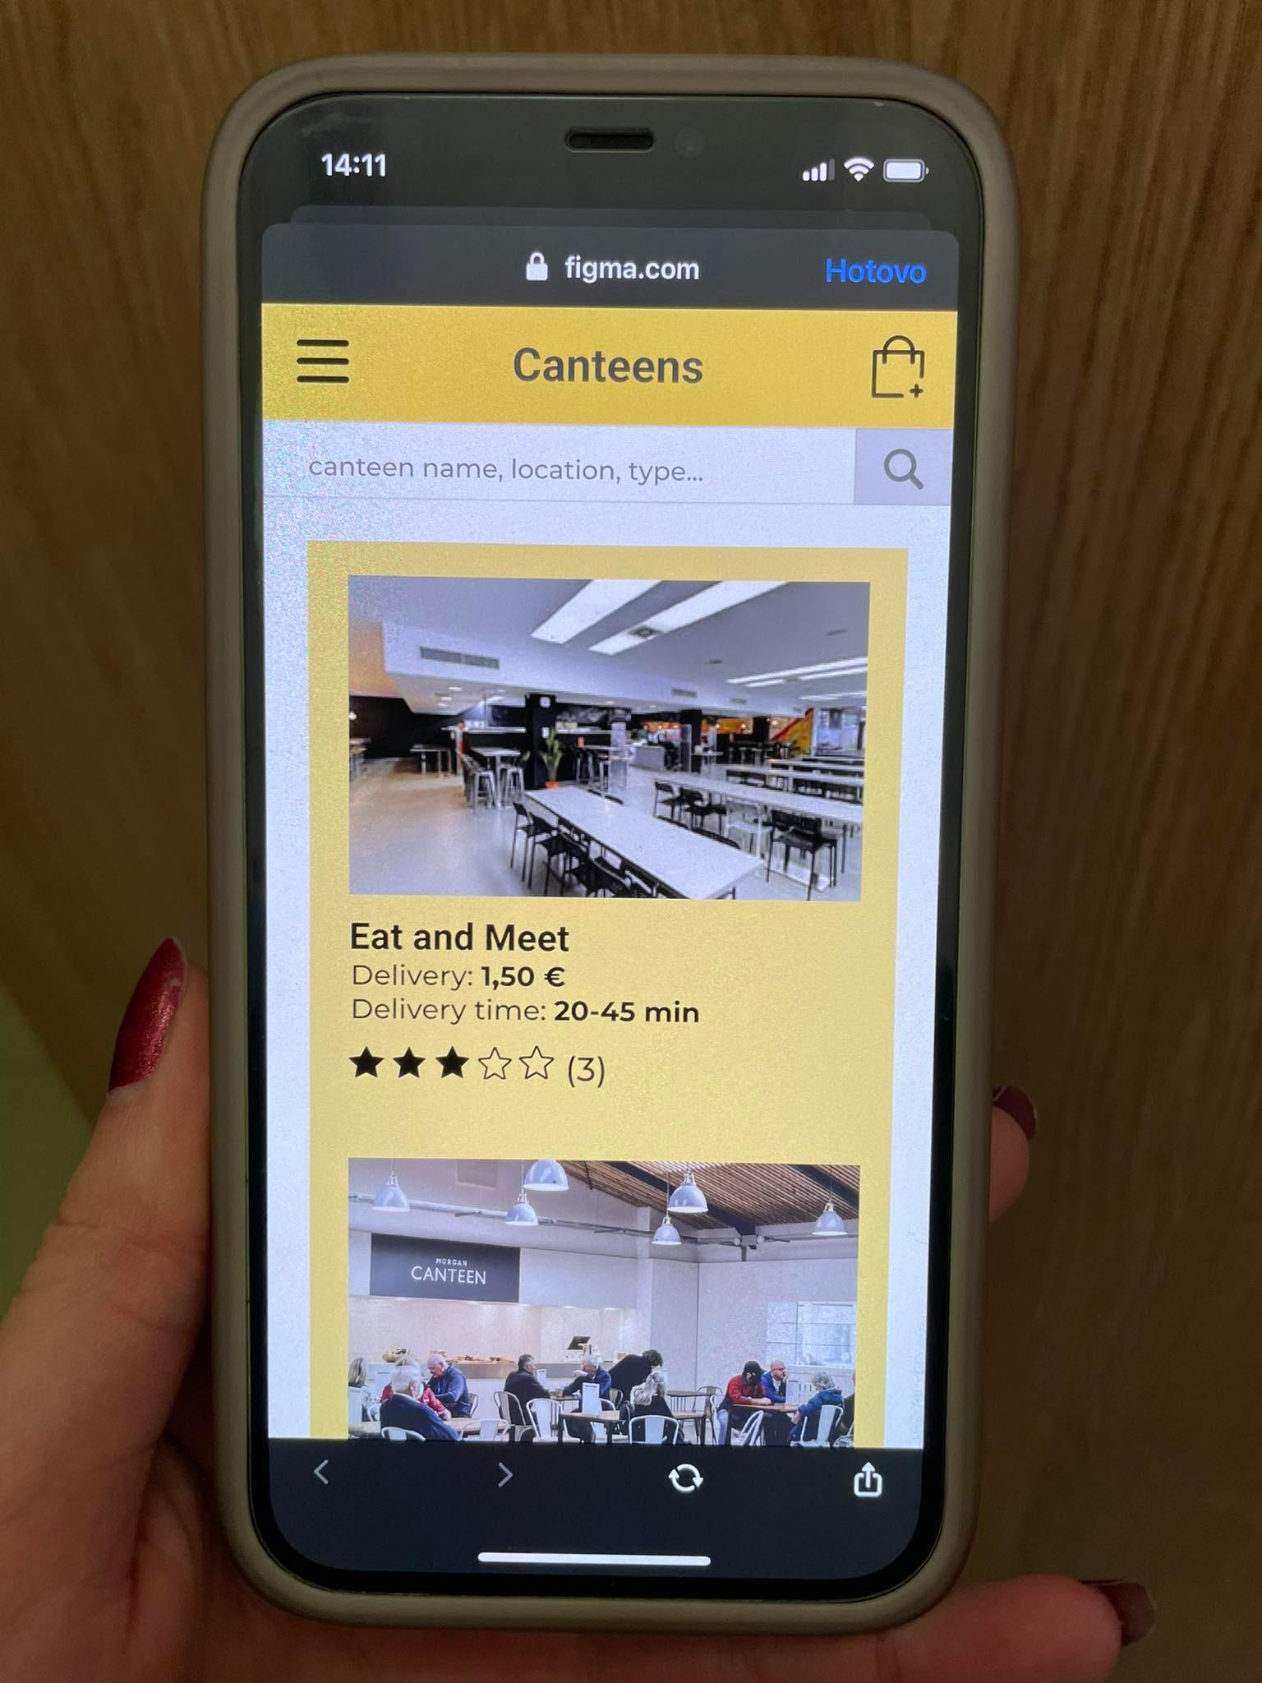

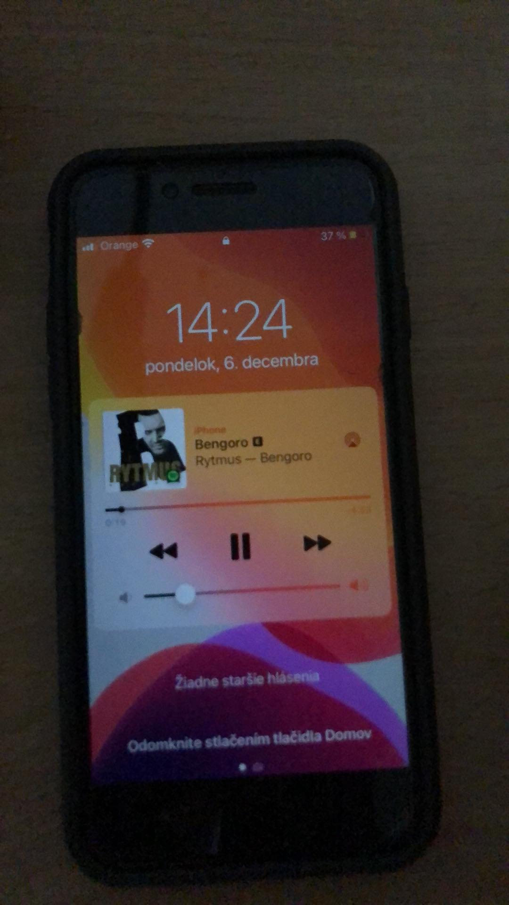**TP3**

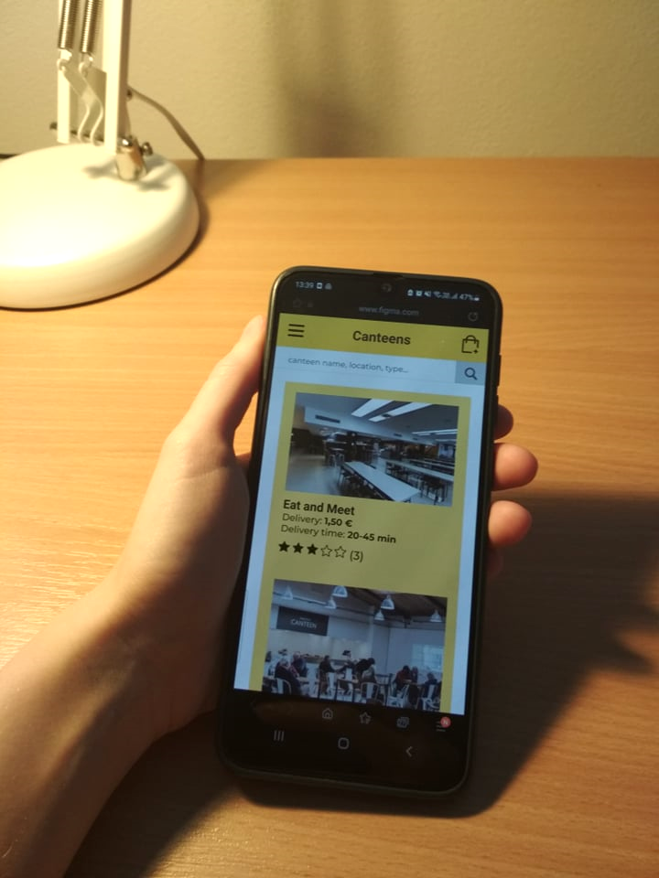**TP4**

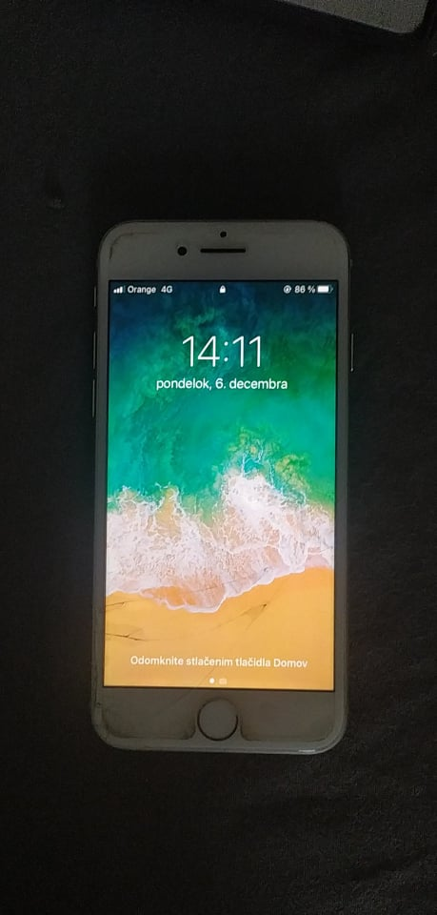**TP5**

### **Tasks**

**The task** list used by the test team is shown in Table 3**.   
Only the description of each task is given to the users.**

| **Task No.** | **Description** | **Prerequisites** | **Completion Criteria** | **Max. Time** | **Possible Solution Path** |
| --- | --- | --- | --- | --- | --- |
| 1 | [Impressions]  Please go to the app:  *Eat not meet*  and spend a few minutes looking around. | Mobile app *Eat not meet* opened at homepage  User is logged into his personal account. | User indicates they have finished looking around or time has elapsed.  The facilitator then asks the user questions:   1. Whom is this app intended for? 2. What does this app offer? | 1 minute |  |
| 2 | Order a meal from a list of your favourite meals. | Mobile app *Eat not meet* opened at homepage.  User is logged into his personal account. | User sees confirmation of the meal order.  The facilitator then asks the user questions:   1. How hard was it to order the meal? 2. How hard was it to look up the list of your favourite meals? | 2 minutes | Homepage  -> Favourites  -> Click on Order again and add it to cart  -> Go to cart  -> Click continue  -> Click continue -> Click confirm and pay |

**Table 3:** Task list.

### **Interview Questions**

1. How did you find the appearance of the application?
2. Which parts of the application did you find confusing or frustrating?
3. What did you like about the application?
4. What changes would you suggest to make in the app?

**Metrics**

**Completion rate:**Both tasks were completed without problems or help from the facilitator. Testers didn’t need further information and didn’t hesitate at any point of the tasks.

**Completion time:**Both tasks were completed within the given time. Some of the testers were able to complete the tasks faster than others, which probably means that they had more experience with similar applications.

**Feedback questionnaire**:  
Appearance of the application received the highest rating. Users appreciated the minimalistic design and enjoyed the chosen color scheme. They also said that the layout was very easy to understand and navigate.   
Second highest rated was the payment process, which most of the users rated as very comfortable. Others didn’t feel very comfortable with entering their credit card information or would like to have the option to save it for later.  
Lastly, the testers compared the applications such as *wolt* or *bistro* and rated the ordering process to be slightly less satisfactory.

## **Results**

### **Discussion and Analysis**

Users were satisfied with the majority of our applications features. They suggested changing just 2 things. One user suggested changing the layout of *favourite foods*, deleting the remove button and replacing it with a cross on the top left part of the picture of food. Other testers also suggested adding an option to save their credit card information.

### **Task Completion rate**

|  | **Task 1** | **Task 2** |
| --- | --- | --- |
| **TP1** | 1 | 1 |
| **TP2** | 1 | 1 |
| **TP3** | 1 | 1 |
| **TP4** | 1 | 1 |
| **TP5** | 1 | 1 |
| **%** | **100** | **100** |

**Table 5:** Task completion rates ( 0 - not completed, 1- completed, *0.5 - assistance was given*.)

### **Task Completion time**

### *Time measured in seconds*

|  | **Task 1** | **Task 2** |
| --- | --- | --- |
| **TP1** | 38 | 31 |
| **TP2** | 30 | 48 |
| **TP3** | 35 | 51 |
| **TP4** | 43 | 45 |
| **TP5** | 32 | 29 |
| **Avg** | 35,6 | 40,8 |
| **Std** | 4,59 | 9,04 |

**Table 6:** Task completion time

### **User Interviews - answers to the facilitator**

| **TP1** | Really nice, I liked the combination of white, yellow and black. |
| --- | --- |
| **TP2** | Very nice. |
| **TP3** | It was quite nice, I liked the color combination. |
| **TP4** | I liked it, the color scheme was very nice. |
| **TP5** | I liked the layout, also the colors were nice. |

**Table 7a:** User responses to the question 1:   
How did you find the appearance of the application?

| **TP1** | None, everything was clear. |
| --- | --- |
| **TP2** | I would like to click on more buttons. |
| **TP3** | It was frustrating that I could not click on more buttons or use the menu. But for my task everything was ok. |
| **TP4** | I wasn’t confused at all. Everything was understandable and easy to use. |
| **TP5** | It’s a nice application with clear navigation, I wasn't confused nor frustrated. |

**Table 7b:** User responses to the question 2:   
Which parts of the application did you find confusing or frustrating?

| **TP1** | I liked the ease of use and adding foods to favourites for a faster ordering process. |
| --- | --- |
| **TP2** | Nice appearance. |
| **TP3** | Mostly the appearance. |
| **TP4** | I liked the minimalistic design and the fact that you can save your favourite meals. |
| **TP5** | Probably the layout and clear navigation. |

**Table 7c:** User responses to the question 3:   
What did you like about the application?

| **TP1** | I would remove the remove button from favourites, switch it for cross, so the photo could be bigger. |
| --- | --- |
| **TP2** | Nothing, everything was clear. |
| **TP3** | Maybe I would add a fixed footer. |
| **TP4** | I would add an option to save my card info to my profile so that I don’t have to type it in every time. |
| **TP5** | I have no idea. |

**Table 7d:** User responses to the question 4:   
What changes would you suggest to make in the app?

### **Feedback Questionnaires**

Table 7 shows a summary of the ratings given by users in the feedback questionnaire at the end of the test. The neutral scale in the original feedback questionnaire has been mapped to a weighted scale between 6 (best) and 0 (worst)

|  |  |  |  |  | **TP1** | **TP2** | **TP3** | **TP4** | **TP5** | **Mean** | **Std. Dev** |
| --- | --- | --- | --- | --- | --- | --- | --- | --- | --- | --- | --- |
| 1. | Did you like the visual part of the app? | A lot | 6   5   4   3   2   1   0 | Not at all | 6 | 6 | 6 | 6 | 6 | 6 | 0 |
| 2. | Did you find food ordering process  easier compared to similar applications? | Much easier | 6   5   4  3   2   1   0 | Much harder | 5 | 4 | 4 | 5 | 4 | 4,4 | 0,49 |
| 3. | Did you find the payment process comfortable? | Very comfortable | 6   5  4  3   2   1   0 | Very uncomfortable | 6 | 6 | 5 | 6 | 5 | 5,6 | 0,49 |
| 4. | How likely are you to recommend this app? | Very likely | 6   5   4  3   2   1   0 | Very unlikely | 6 | 5 | 5 | 6 | 6 | 5,6 | 0,49 |

**Table 8:** Summary of user ratings from the feedback questionnaire.

### **List of Problems Found**

1. No option to save the credit card information.
2. Unnecessary buttons in Favourite foods screen (replace Remove button with X in the corner).